**Term Paper Report**

**On**

**Latest approaches on Block Chain**

**Submitted to:**

**Amity university, Uttar Pradesh**



**In partial fulfilment of the requirements for the award of the degree**

**Of**

**Bachelor of technology**

**In**

**Computer Science Engineering**

**By**

**Deeksha Bisht**

**(A2305220629)**

**Under the guidance of**

**Mr. Paurush Bhulania**

**Department of Computer science and engineering**

**Amity school of engineering and technology**

**Amity University, Uttar Pradesh**

**August 2021**

**DECLARATION by the STUDENT**

I, Deeksha Bisht student of B.Tech CSE hereby declare that the project titled “Latest approaches of Block Chain” which is submitted by me to Department of Computer Science and Engineering, Amity School of Engineering and Technology, Noida, Amity University, Uttar Pradesh, in partial fulfilment of requirement for the award of the degree of Bachelor of Technology in Computer Science Engineering, has not been previously formed the basis for the award of any degree, diploma or other similar title or recognition.

The author attests that permission has been obtained for the use of any copy righted material appearing in the report other than brief excerpts requiring only proper acknowledgment in scholarly writing and all such use is acknowledged.



Place: Noida Deeksha Bisht

Date: 01.08.2021 Enrolment number: A2305220629

2020-2024

CSE-6-Y

**Certificate**

On the basis of the declaration submitted by Deeksha Bisht (Enrollment number:A2305220629), student of B.Tech Computer Science and Engineering. I hereby certify the report entitled “Approaches of Block Chain”, which is submitted to the department of Computer Science and Engineering, Amity school of Engineering and Technology, Amity University, Noida, Uttar Pradesh in partial fulfilment of requirement for the award of the degree of Bachelor of Technology in Computer Science and engineering is an original contribution with existing knowledge and faithful record of work carried out by him under my guidance and supervision. To the best of my knowledge this work has not been submitted in part or full for any degree or diploma to this university or elsewhere.



(Paurush Bhulania)

Assistant Professor-II, ASET

AUUP, Noida

**Index**

|  |  |  |  |  |
| --- | --- | --- | --- | --- |
| Serial number | Contents | | Page number | |
| 1. | Abstract | | 5 | |
| 2. | Introduction | | 6 | |
| 3. | History | | 7 | |
| 4. | Architecture of blockchain | | 9 | |
| 5. | Working of blockchain | | 10 | |
| 6. | Bitcoin and Libra | | 11 | |
| 7. | Merits and Demerits | | 13 | |
| 8. | Conclusion and review | | 14 | |
| 9. | | References | | 14 |

Abstract

Blockchain is a database, digital ledger system that serves as the building block on which cryptocurrencies works. It is known as a chain because additions or changes are performed linearly and connected together. This means the blockchain cannot be immediately edited or changed. As the transaction starts, the parties cannot reverse or modify it without the consent of all the parties involved.

Blockchain in today’s view has increased security and privacy, speed by removing intermediates with the access to trace in the global market. Customers from all fields are able to experience fast and less costly settlement with industry’s services. Data stored on many computers has made it impossible to hack which increased the security of data.

Bitcoin was the first blockchain network introduced in 2009. Originally, it was used to provide an easier way for banking industry to work. Now, Blockchain is also used to reduce the complexity of any problem.

Though being highly efficient, blockchain has some major drawbacks. With high latency(long delays in network transmissions) and frequent orphaned blocks(fail multiplication of the chain) is quite a major problem in today’s hectic world.

INTRODUCTION

What is Block chain?

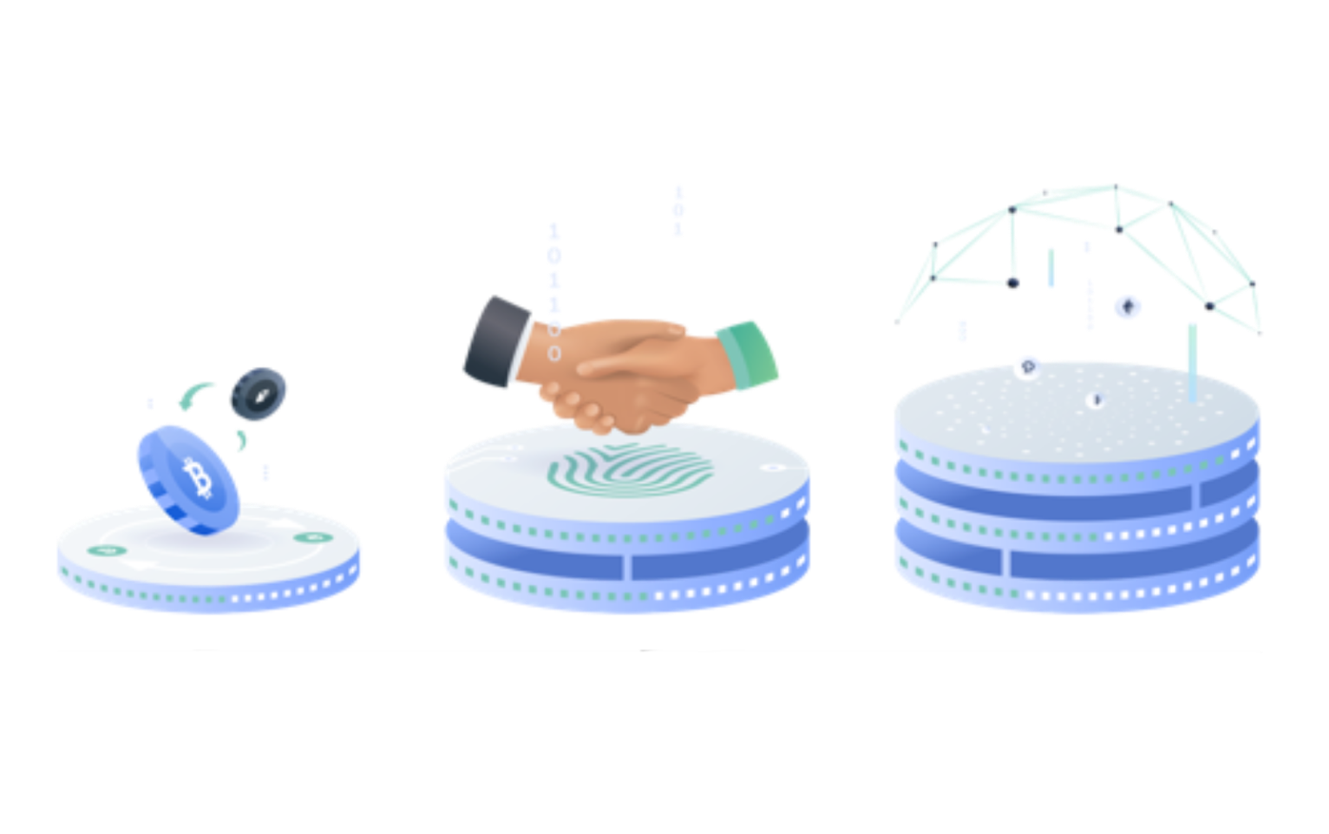

A database used for a specific purpose, a distributed ledger technology (DLT), an aspiring technology which has created the existence of cryptocurrency. A digital asset which keeps an unaltered technology which has ease the transactions in banking industry. Now a days, blockchain technology has moved to a greater aspect rather than being on banking industry. This technology has now taken its significant in almost all the industries, from food to medical facilities. It is called a chain because new data is added to the end of the previous information.

It stores encrypted block of data which once entered cannot be altered without the concern of the parties involved. It is an end-to-end encryption that is no third party is involved like the concerned bank. Data in these blocks can only be read and not corrected.

Block chain is not just about cryptocurrency anymore. It allows a new perspective on human interactions to society trading.

Blockchain is a software arranged protocol. It does not work without internet. It is called meta-technology as it interferes which other technologies.

History

In 2008, a group of anonymous hackers with the name Satoshi Nakamoto demonstrated the concept of cryptocurrency. Simply managing the physical tokens—bills, coins—equals possession, and it’s up to the people to exchange transactions among themselves physically. As long as cash is difficult to replicate, it is not necessary for a complete accounting of who owns what amount of the money, or the details of the various holders. However, if you could piece together who held every bill, then the requirement of the physical representation is useless. Banks and payment processors have already minimally changed our physical in their private system.

By 2014, Blockchain technology is separated from the currency and its potential for other financial, inter-organisational transactions is explored. Blockchain 2.0 was born, referring to its applications beyond currency.

The Ethereum blockchain system introduces programs in blocks, representing financial instruments such as bonds. These bonds are now known as smart contracts.

Generations of Block Chain

First generation- Bitcoin

The implementation of DLT (distributed ledger technology) has led to its first and only use: cryptocurrencies. This allowed financial transactions based on blockchain technology. Bitcoin is the most prominent example in this category.

Second generation- Ethereum

Other blockchains include those that run on hundreds and hundreds “altcoins” – other similar currency projects with different rules – as well as truly different application, such as Ethereum, the second largest blockchain that is implied after the first generation project-Bitcoin. Ethereum circulates a special currency called ether, and also allow the storage and operation of computer code, allowing for smart contracts.

Third generation- Cardona/PolkaDot/Ehthereum2.0

While the first and second generation are exceptional in innovation, there are a couple of small but impactful fundamental problems that they suffer from. One of the highly concerned drawback is-Scaling. There are a large amount of people trying to transact and scarce space for it on the blockchain.

Third-generation blockchain projects are designed to eradicate the problem in which the technology automatically resolves the issues of scaling if they appear.

Another solution which the third-generation blockchain projects provides is interoperability. The first loops of the blockchain can’t interact with each other. Interoperability is actually a very important factor for the industry to thrive.

Projects like Cardona and PolkaDot introduced interoperability that is ability of computer to exchange information, functions into their blockchain so that they can work with other blockchains efficiently.

-What is Cryptocurrency?

A cryptocurrency is a form of exchange of currencies. Traditional currencies as INR, USD are traded but it is also designed to exchange digital information through a process that has made available under certain principles of cryptography. Apart from this, cryptocurrency is a digital currency and is categorised as a part of alternative currencies and tangible currencies.

Cryptocurrency is a carrier vessel based on digital cryptography. In this type of cryptocurrency, the owner of the money holds its ownership. No other type of record is kept as the same identity of the owner. In 1998, Wei Dai issued "B-Money," an anonymous, distributed electronic cash system.

-Why do we need Blockchain?

1. **Strength:**Blockchain is a frequently duplicated architecture. The chain is still used by many nodes in the hour of a huge attack on the system.
2. **Reduction of time:**In the financial industry, blockchain can play an important role by allowing a faster settlement of trades as it does not need any long processes of verification, settlement, and clearance. A single version of agreed-upon data of the share ledger is available between all stack holders.
3. **Reliable:**Blockchain verifies and guarantees the identity of the interested parties. This removes duplicate records, reduces rates and increases transaction speed.
4. **Avoid scamming :**The idea of sharing information and consensus avoid possible losses due to fraud. In logistics-based industries, blockchain is used as a monitoring mechanism to reduce costs.
5. **Transparency:**Changes to public blockchains are available to be seen by everyone. This offers greater transparency, and all transactions are immutable.
6. **Collaboration** – Allows parties to co-operate straightaway with each other without any interference of third party.

Architecture of Block Chain



Main keywords in Blockchain are

1. Block

A block is an entity which keeps record of the data. The type of data stored on the blockchain depends on the type of blockchain used. The first block of chain is called genius/geneses block. Each block is connected to its predecessor block in order to create a link between data. A whole block of 32-bit is called nonce which is randomly generated that creates a cryptographic header hash. A 256-bit hash number is attached to the nonce. It starts which a lot of zeroes implementing extremely small quantity.

1. Miners

New blocks on the chain is created by miners by the process called mining. Blockchain provides a unique nonce and hash to every block. It also has a reference hash of the previous block in chain which makes it to collect blocks, especially on large scales. The nonce is 32-bit and hash being 256, hence creating an estimate of four billion possible nonce-hash combinations that is mined before the right one is found. It is almost impossible to alter block chain because while applying a change to any block, the chain requires re-mining of not just the block with the change required but all of the blocks that come after.

1. Nodes

One of the most crucial factors in blockchain technology is decentralization. Block Chain cannot be owned by any computer or organisation. It is a distributed ledger which is connected through nodes and are additionally linked to the chain. Nodes are electronic devices of any kind that keeps a transcript of blockchain keeping the network functioning. Every node has its own issue of the blockchain network which is algorithmically approved by default. Any newly mined block on the chain is to be updated, verified and trusted. Every action can be easily checked and viewed because blockchain is transparent. Each user is given an unique alphanumeric identification number that shows the each participant’s transactions. The Combination of public information with the system of verification-and-balance helps the blockchain maintain its integrity and creates trust in users.

Working of Blockchain

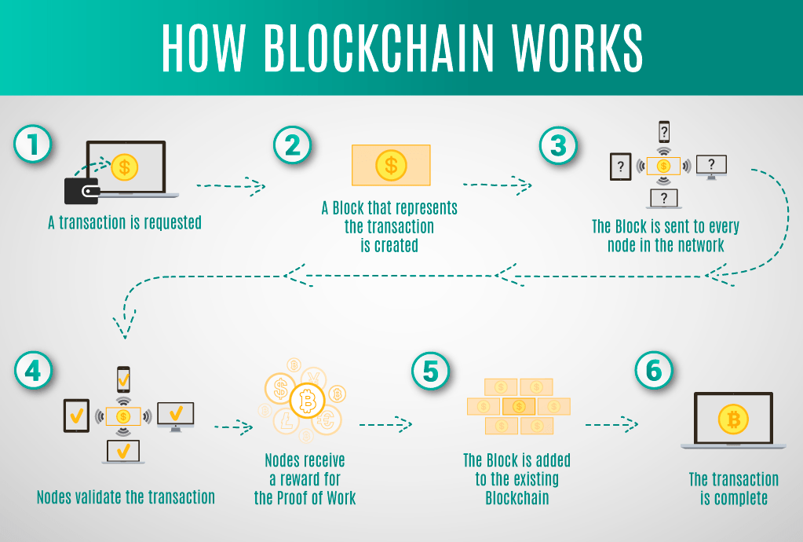

1. A person applies for a request of transaction. The transaction can be of cryptocurrency, records of customers, contracts or other information.

2.The requested transaction is transmitted to a person-to-person (P2P) network with the help of nodes.

3.The network of nodes confirms the transaction and the user's status by the help of known algorithms and protocols that are already designed.

4.As soon as the transaction is complete, the newly created block is added to the existing blockchain. This makes the data imprint permanent and unalterable.

-BITCOIN and LIBRA

 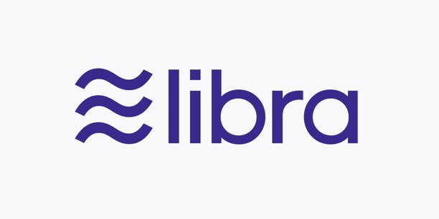

Technologies like BITCOIN,LIBRA are few of the digital currencies which rose to fame quite recently. People need an easy way to earn money without putting in much hard work.

**BITCOIN** first evolved in 2009.Investing in Bitcoin is a risky way but worth earning a fortune. The current status of one bitcoin is 31,58,455.86 rupees.(dated 05.08.2021)

1. In 2009, the first ever successful transaction using Bitcoin occurred between computer scientist Hal Finney and the al-famous Satoshi Nakamoto.
2. In 2011,1 BTC=$1 USD giving cryptocurrency parity with US dollar. By 2012, the terms blockchain and cryptocurrency were mentioned in the popular television show “The Good Wife”.
3. In 2013,BTC market surpassed $1 billion with bitcoin reaching $100/BTC for the first time.
4. In 2017, Bitcoin reached its all-time high $19,738.21/BTC. Dubai announced its government will be blockchain-powered by 2020.
5. In 2020, Bitcoin almost reaches $30,000 by the end of 2020.PayPal announced that it will allow its users to buy, sell or keep their cryptocurrencies. The Bahamas became the world’s first country to launch its central bank digital currency, correctly known as the “Sand Dollar”. Blockchain becomes a X-factor in this current fight against COVID-19, mainly for securely and storing medical research data and patient information

**LIBRA** is a cryptocurrency launched by Facebook. It is intended as a simple, low-fee global currency used among the participants.

Tokens are monitored and are kept being tracked by the non-profit organization known as the Libra Association. As participants exchange their local currency for tokens, the association will ensure that the tokens are backed up by a basket of major currencies and security. The basket allows the cryptocurrency to have a relatively stable price.

What makes Libra a different cryptocurrency?

Libra cryptocurrency is different from other blockchain because of its real assets. Many cryptocurrencies lack this feature hence creating a lack in the stability and guaranteed intrinsic value that Libra offers. Nearly all of the cryptocurrencies are backed up at the end by real assets which are further linked to a single currency. Libra on the other hand, uses major currencies and government debt insurances. This can be also managed by associations like Visa, Master card, PayPal and Ebay. The association linked is only in power to delete records.

Application of Block Chain

1. Cryptocurrency exchange: big amount of money exchange
2. Voting mechanism: the anonymity of user with transparency for user.
3. Cross-border payments: the easiness of transferring money and data by one click.
4. Securely sharing medical data: it is impossible to hack the blocks hence secure sharing.
5. Real-time IOT operating system: the transitioning taking place is shown real time giving accuracy with time to plan ahead.

More applications of Block chain are:

1. NFT marketplace
2. Music royalties tracking
3. Anti-money laundering tracking system
4. Supply chain and logistics monitoring
5. Advertising vision
6. Original content creation
7. Real estate processing platform

Current status of Blockchain in India

Cryptocurrencies is legal in India as stated in an article in Business Today published on 20 may,2021. So, trading, buying and selling bitcoins is possible from any part of India. However, India does not have a stable framework to look over cryptocurrencies as of now. A bill was flagged on 2 November,2017 issuing the positive attributes of DLT technology and suggest numerous application most of them in the finance sector. Though, the centre have raised flags for the misuse and wanted to ban major part in India. RBI governor, Shaktikanta Das has said that India is working towards developing its own digital currency.

Merits

1. Frequent verification of transaction: transactions are checked every 15-25 minutes through mining.
2. Decentralized structure: no one knows or trust anyone. Each member in the network has a copy of the exact same data in the form of a distributed ledger. If a member’s ledger is altered or corrupted I any way, it will be rejected by the majority of the members in the network.
3. Improved security: an unalterable record is created for the smooth functioning of end-to-end transaction. Moreover, blockchain can address privacy concerns better than traditional computer systems by anonymising data and requiring permissions to limit access.
4. Reduced costs.
5. Immutability: transactions once recorded on blockchain cannot be changed or deleted. The date on the blocks is stamped which is used to track information over time enabling a secure, reliable audit of information.
6. Tokenization: value of an asset is converted into a digital token that is then recorded on and shared via block chain.

Demerits

1. Not a distributed computing system: Blockchain network depend on nodes to work properly. The quality of the nodes is a key factor to determine the quality of the blockchain. Blockchain is a distributed network, but it lacks the feature that makes a distributed computing system beneficial for corporations.
2. Scalability: the more people or nodes join the network, the chances of slowing down is more.
3. Consume too much energy.
4. Mining does not provide network security: due to too much data floating in the chain, will mining it creates a probability to get hacked easily.
5. Not indestructible: once a block is created it can only be altered after consultation but cannot be destructed. Hence, space is wasted.
6. Anonymity is not present

Review and Conclusion

Block chain created a revolutionary era in the industry where money is everything. The ease of transaction and privacy attracts parties to deal among each other hence increasing the economy of the country. The more the complex this technology is, the more it is easy to use.

Seeing how blockchain is a secure way for data safety and cryptocurrency, this technology is now not only limited to banking but to every field.

Blockchain is such an innovative platform for business relationship, buyer-seller relationship. A new wave of trust flows among people to come forward and ease their work.

References

1. <https://builtin.com/blockchain>
2. <https://www.ieee.org/membership-catalog/productdetail/showProductDetailPage.html?product=CMYBLK776>
3. <https://www.guru99.com/blockchain-tutorial.html>
4. <https://spectrum.ieee.org/blockchains-how-they-work-and-why-theyll-change-the-world>
5. <https://builtin.com/blockchain>
6. <https://searchcio.techtarget.com/feature/Top-10-benefits-of-blockchain-technology-for-business>
7. <https://www.businesstoday.in/latest/corporate/story/cryptocurrency-in-india-what-the-govt-stand-legal-status-its-future-296570-2021-05-20>